

SIMATS ENGINEERING

Saveetha Institute of Medical and Technical Sciences
Chennai- 602105

Student Name: Shyam sundhar. Y Reg. No.:192424082
Course Code: CSA0603 Slot: A
Course Name: Design and analysis of algorithm
Course Faculty: Dr. P. Solainayagi
Project Title: AgroPlan-X – Intelligent Multi-Crop Plantation Planning and Resource Optimization
Module Photographs: (4 photographs – Module 1, Module 2, Module 3 and Module 4 implementation screenshots)
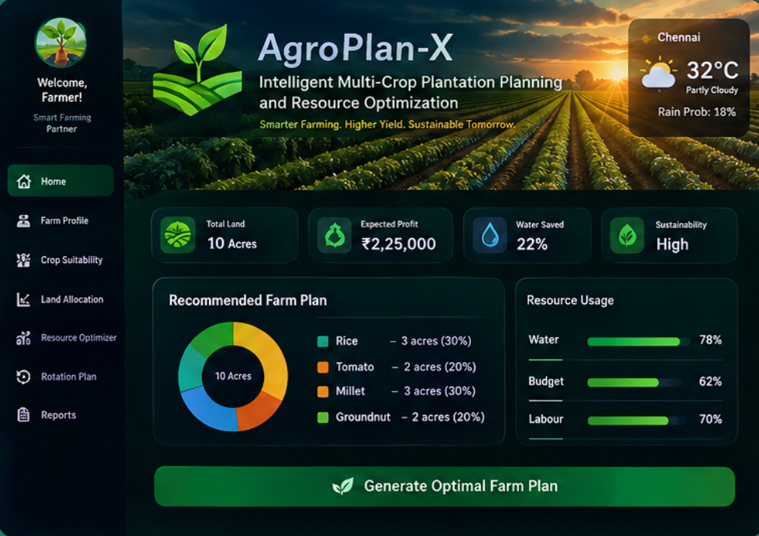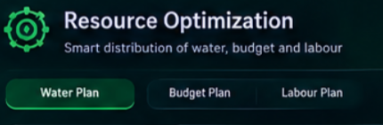
Project Description:
AgroPlan-X is an intelligent agricultural planning system designed to optimize multi-crop plantation.
It uses AI and Machine Learning to recommend suitable crops based on soil, weather, and environmental conditions.
The system optimizes land, water, fertilizers, labor, and budget for efficient farming.
It predicts crop yield and estimates the expected cost, revenue, and profit.
AgroPlan-X helps farmers make data-driven decisions and achieve sustainable, profitable crop production.
Module 3: Water, Budget & Labour Optimization:
Resource Optimization
• Calculates water, budget, and labour requirements for each selected crop.
• Uses Knapsack and Greedy strategies to prioritize high-value choices under limited resources.
Smart Resource Management
• Measures resource utilization and identifies plans that reduce wastage while maintaining farm value.

Student Signature Guide Signature

